Summary of a long time ago

***Previously:***

*Theon, Fiora, and Kyrat had a special mission on their hands—the rescue of Moog from the dungeon of* ***Kramlik****… The guard showed them in, but explained that they needed to leave their weapons with him—and that the animals should stay outside. Fiora gives her pack and weapons to Flame, tying the backpack around the jaguar…Up the stairs was a small, open waiting area outside of a large office—Kramlik’s office. The guard opened the door, beckoned them in, and closed the door behind him.*

*The room was a mess—a personal workshop for an ingenious engineer. Gears were strewn about the shelves, bronze tools and artifacts lay on tables, and large pieces of machinery sat in corners. One corner held what looked to be a clockwork humanoid, its bronze body sleek and shimmering…Kramlik sat, breathing heavily. His eyes narrowed under his glass goggles. “You are…a friend to this wizard? He…attempted to swindle me. I do not…appreciate his dishonorable ways. In addition, …he seemed to know more about this situation…than I would like. He is here…held up in my tower…He and his guard led them up the tower stairs off his office, and they came to the top of the tower. The room was dark with no windows. The air was heavy and dark. The room was divided into prison cells, holding Moog and one other, a venerable elf…Fiora immediately went to the bars and began to heal Moog, but Kramlik’s guard shoved her away…This is where it went downhill. Fiora had a grudge—no one shoves a ranger.*

*…the tension snapped…*

*Kramlik’s guard raised his sword to attack. Kyrat, weaponless, lunged at the guard to grab his weapon…Fiora threw a dagger that dug itself into the dwarf’s back…Kramlik grasped the stump of his wrist, his hand severed by Theon’s blade…Moog cast an enchanting spell on Kramlik, causing him to laugh uncontrollably, unable to call for help or stop laughing. Kyrat dug his thumbs into the eye sockets of the guard as he screamed. Theon hurriedly swept Kramlik’s desk for papers and artifacts, taking a small bronze ball contraption and some schematics.*

*…Before any help could arrive, Kyrat, Moog, Theon, Fiora, Flame, Frostbite, and the old elf were gone out a window…*

Theon opened the letter he found on **Kramlik’s** desk, breaking the black-ink seal pressed with the letter ‘N’:

*Kramlik,*

*I have another task for you. An object once lost to time has come again to the minds of the present. The crown of the last river kings was lost hundreds of years ago, but it can be found again—and you will find it. The crown was lost in the sinking of the king’s palace when Elion the Uniter first moved on the Riverlands. The crown was studded with thirteen rubies known as Merenion’s Tears. These rubies are of immense power when paired with the circlet, but alone they are weak. Find these rubies and the circlet, and you shall be payed a sum more than anything you could imagine.*

*We look forward to what you can provide.*

*-------*

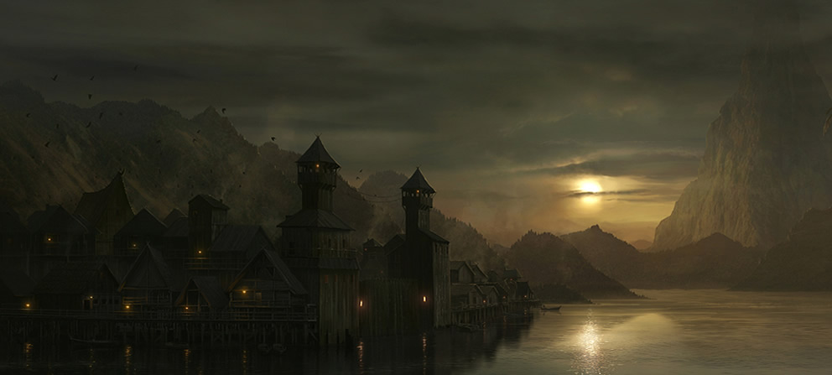

*Riverdeep*

The group gathered in the inn—all together once again. Rain tapped lightly on the wooden shingles, the only sound in the uneasy silence. Each of the group knew that something had to be done—**Kramlik** was still out there, and he needed to be stopped. If he found the crown, Riverdeep would surely fall to the orcs.

The group discussed courses of action and came to a compromise: they would convince **Earl Veragul Pearly** and **Lady Bynnoa** to meet and join forces to take down **Kramlik**. They split up, some going to the **Earl’s**, others going to **Lady Bynnoa.**

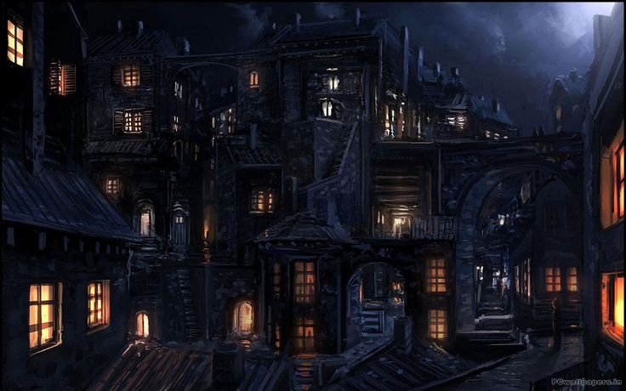

*Riverdeep’s Streets*

As one group quickly moved through the streets to go to the **Earl’s** mansion, they heard something—quick gasps of breath and thuds of arrows, as if people were being murdered behind them. Raime and Moog investigated, and found the freshly killed bodies of **Kramlik’s** mercenaries, pierced by arrows. Moog climbed onto a nearby roof to investigate—and ran straight into an assassin! The mercenary moved towards Moog, but slipped as Moog threw a bagpipe in his face. As the man slipped, an arrow slammed through the bagpipe and into his face. The mercenary went limp and splashed into the watery canal below. The group moved faster through the streets of Riverdeep, knowing they were being followed.

The group made it to the Earl’s mansion, and explained the situation to the guards out front. They glanced at each other, and led the group inside with the assurance that they would double the guard and watch for the assassins.

The meeting with the **Earl** went well, and he was convinced to go out and meet **Lady Bynnoa** to discuss the fate of **Kramlik**.

The half of the party that made for **Lady Bynnoa’s** guildhouse moved through the streets stealthily, throwing off any pursuers. They were welcomed into **Lady Bynnoa’s** hall, the night leaving the rooms empty. The adventurer’s footsteps echoed in the gallery hallways. They met with **Bynnoa**, and Ander’s silver tongue once again seduced the powerful woman to heed his will. She was willing to meet with the **Earl** immediately.

Two of the most powerful parties in Riverdeep stepped out into the city’s streets, the rain still coming lightly down on the scene. The two groups met in a grassy park, the ground soft with mud. **Lady Bynnoa** stepped forward, “So? What will be of Kramlik? If he goes, who shall head the Craftsman’s Guild? I have some propositions…”

The discussion began, and the fateful meeting in the park decided the fate of the entire city. At the center of the negotiations stood Ander, the veritable diplomat, leading the two factions towards a solution. That solution was to move on the Craftsman’s Guildhouse itself, that very night. **Kramlik** could not be allowed to move forward with his plot to deliver Merenion’s Tears to **this outside party**.

The twenty-five guards and mercenaries moved behind the party through the streets of Riverdeep. **Lae Duff** and four more men joined them from dark alleyways. The elf approached Dr. Moe, “I’ve always wanted to take **Kramlik** out…The dwarf has it coming to him.” The force spreads themselves around the Craftsman’s Guildhouse quietly, **Lady Bynnoa** and her men find vantage from a building across the canal. They ready their bows to take out any of **Kramlik’s** men who try to escape. The **Earl** and the captain of the guard **Brognon** position their soldiers in a line outside the front doors of the guild. The adventurers make the bold move to move in and flush out anyone inside.

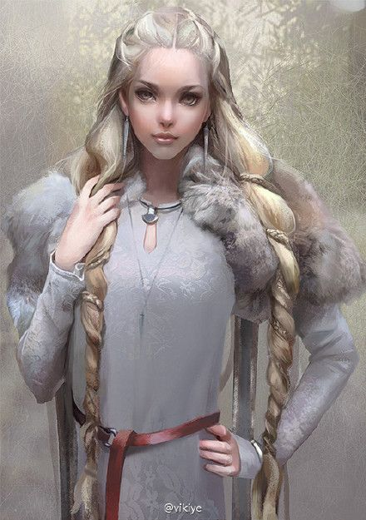Fiora sits next to **Lady Bynnoa**, pointing an arrow directly at **Kramlik’s** office window. Moog sneaks along the building and begins to scale the side, grabbing hold of the window sill of **Kramlik’s** office. The wizard pulls himself in, careful not to disturb any of the metal contraptions on **Kramlik’s** desk. The room is dark, silent, and empty.

As Raime, Kyrat, Theon, Ander, and Dr. Moe moved throughout the building, they found it dead. The halls were dark and cold, and the rooms were empty. The only sound was that of the rain on the roof top.

Ander walked slowly outside, searching for any remnants of what happened to the residents of the building. He stood by the water, looking down into the darkness. The black liquid splashed softly against the wooden foundation…but someone was off. Ander kneeled, and looked closer: small pinpoints of light had appeared in the water, slowly growing larger. One, two, then three points of light appeared. They grew faster and faster, as if emerging closer. Quickly, he stood and cast a spell to alert **Lady Bynnoa** and Fiora of what was happening. The lights grew larger still.

Kyrat and Theon moved into the back storeroom, taking advantage of the situation to loot the building. Theon was searching for a bow when he saw papers fluttering on a table, a breeze from outside blowing in. The papers were schematics for an underwater suit and a submarine. Next to the desk, numerous suit racks stood empty. The suits were gone, and with them **Kramlik’s** minions. They had to get out.

Lae Duff

Just as they turned to leave, Ander rushed in and warned them of the lights—**Kramlik** was below the city. Suddenly, the entire building shook. Wood cracked and burned as a hole was torn through the guildhouse from below. A great beam of energy burst through the floor, continuing through the ceiling. **The Earl, Brognon, and Lady Bynnoa** gasped, shocked as the beam illuminated the sky above Riverdeep, eventually dissipating into the clouds. Those inside the guildhouse grabbed onto the walls to steady themselves. They held their breath, the burst followed by utter silence. The building rocked back and forth in the water, splashing the boardwalks alongside it. Then a second burst ripped through the building, followed by a third. The building was split and splintered as the adventurers inside scrambled to get out. More beams of energy ripped through the building, barely missing those scurrying to escape. The Craftsman’s Guildhouse burned in the night, torn apart by **Kramlik’s** power.

The party met with the factions in the aftermath of the destruction of the guildhouse. The logs of the house still burned and floated in the water as they discussed what to do next. As they argued, **Rohme Reynelis** and **Philaphel** approached.

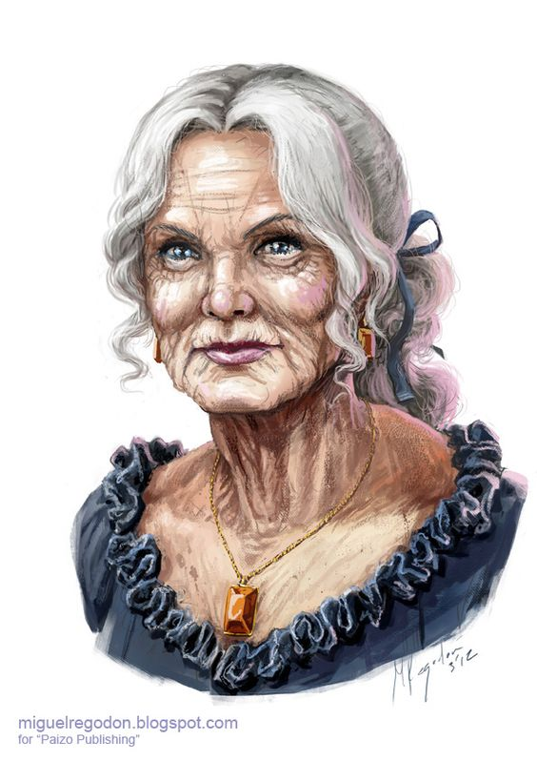

**Rohme** handed the group a slip of paper that **Philaphel** had written on. “The city is not lost yet, and **Kramlik** can still be stopped. You must hurry!”

Raime took the paper:

*“Find one of my symbols at midnight. You shall be brought to my order, and they will tell you everything.”*

The group began to search, but realized that **Bynnoa** was following. Raime and Ander led her off track as the others found one of the symbols.

Rohme Reynelis

Those who continued to find the symbol did not have to trek far—the symbols were all over the city, and Fiora knew the exact location of a few. She led them to the closest one, and they waited until midnight came. As the bells of the city tolled the start of the next day, hooded figures emerged from the shadows. The figures approached and surrounded the party. One stepped forward and made a proposition: “We will lead you to our meeting place and inform you of the truth of the Last Crown of the River Kings, but you must be blindfolded. Those who do not comply will not come.”

Rohme Reynelis

The group accepted the blindfolds, but Moog deviously activated his Hag’s Eye necklace to see exactly where they were going. He saw that they were led in a winding of alleyways to the city’s slum. The leader knocked quietly on a slum door and entered. The party was led downstairs to where the water should be—it was an extradimensional space. In the space, several the hooded figures stood in a circle. The party was set in the center of the circle, and their blindfolds were removed.

A speaker stepped forward, “You have been tasked with seeking the lost crown of the river kings…but you do not know its true power. Should it fall into the wrong hands, Riverdeep will not be the only city to fall to its corruption. The city is not safe with the knowledge of it in the open. The only thing to do now is to find the crown and hide it once more. Your group must do this.

“You, Fiora, know the location of the swamp ruins—but those are not of the first Riverdeep. The original palace and city stood on the banks of the lake hundreds of years ago, when the lake was much smaller. The palace sunk into the swamp, yes, but that swamp is where the center of the Deepening Lake is now. The palace lies at the bottom of the lake, and you must retrieve the crown there. Take these potions to help you breathe in the water. Bring the crown to Philaphel once you retrieve it.”

The quest was on. The group knew **Kramlik** was most likely searching the depths as they spoke, so they had to move quickly. They went to talk to the **Earl** to see if he could ready a ship to take them to the center of the lake, and he approved the motion. Dawn was just breaking as the party boarded the **Earl’s** ship and set out for the center of the Deepening Lake. As the morning fog thinned on the lake, Moog saw another ship following them—**Lady Bynnoa**. Immediately, he knew the guildmaster wasn’t following just to spectate.

As Dr. Moe felt the vibrations of the rubies on his sphincter to find the center of the lake, **Lady Bynnoa** caught up. She called, “I’m here to help! I will send some of my men with Lae Duff down with you, just in case you run into trouble.” And so, the two parties dove: the seven adventurers and six of **Bynnoa’s** mercs.

The water was dark and cold despite the warming summer air. **Lae Duff** swam down quickly, her thin leather armor doing little to obstruct her motion. **Duff** and her men had air bubbles formed magically around their mouths allowing them to breath.

The teams swam down into the depths of the lake until a shape appeared in front of them—a point, the top of a tower. They swam down through the tower, through the sea-weed covered stones of an ancient palace. The hallways twisted into a huge open chamber—the throne room. The walls were crumbled, and the pillars had long since made homes for hundreds of fish. **Duff** whispered a magical phrase as she held a stick, and it suddenly burned light daylight. She dropped the light, and as it sunk the scene became clear. At the end of the throne room was a grand dais surrounded by shattered windows. A lone stone throne stood, and in it sat the long-desiccated skeleton of a king. The light glinted off a slim golden crown on his head, and a deep red glow emanated from a single ruby studding the gold.

The light settled into the sandy floor. Both teams stared each other down, and for a split second both were still. The water was quiet. Then the rope snapped. Moog transformed into a piranha and darted for the crown. **Lae Duff** shed her dreamy elf appearance and transformed into her true form: a werewolf, swimming quickly for the crown. The other adventurers and **Lae Duff’s** mercs dove at each other’s throats, and there was blood in the water. Raime swam towards **Duff** and readied his silver spear—the only weapon among them—except Moog’s silver daggers—that could harm her. Arrows pierced the water, and it was a slaughter. **Lae Duff** was taken down by Raime’s silver spear. Piranha Moog got the crown, a small circlet seemingly woven of thousands of strands of gold, and swam it to Dr. Moe, barely avoiding the grasp of one of **Duff’s** mercs.

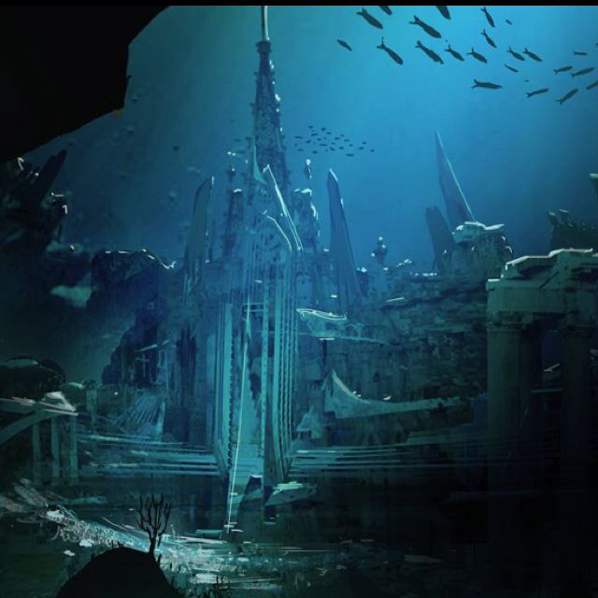

As Dr. Moe put the crown on his head, the rubies that had been stuck so carefully near his sphincter rushed through his body, forcing themselves towards the crown. The jewels embedded themselves in the sockets of the crown, and Dr. Moe could feel them pulse with energy—he focused and let the crown into his mind. He could hear whispers, but the power was overwhelming. A burst of energy emanated from the crown, and **Duff’s** mercs all felt the effects. One seemingly went insane. The other two affected by the crown doubled over in pain before their chests swelled and their hearts burst within them. The battle was over.

The room began to dim as **Lae Duff’s** light rod lost power—the water was lit only by the soft red glow of Merenion’s Tears in the crown. The scene began to get bright, though—a sharp white light came towards the scene. First one point, then two, then three—and then those points of light hit the ruins. Beams of energy from **Kramlik’s** submarine tore through the water and stone and flesh. The bronze sub circled the ruins, firing bolts through it to destroy the adventurers. Immediately, they began to swim upward, dodging the energy rays. Ander stopped and turned towards the machine, and, just as its cannons were preparing to disintegrate him, he moved his hands and whispered a magical spell. The ship seemed to begin to glow red hot, boiling the water around it. The metal warped and bubbled, and boiling water rushed into its bronze halls. Workers and soldiers together were boiled alive, their screams echoing through the dark Deepening Lake. The ship sank to the bottom as the group swam upwards.

As they reached the surface, they found the two ships—the **Earl’s** and **Lady Bynnoa’s**—destroyed by **Kramlik’s** energy beams. **Brognon** was killed, but **Bynnoa** remained. Immediately as the group surfaced, she called to them, “Did you find it? Where is the crown? Let me see it! Let me touch it!” With that, Kyrat swam over to her and clamped his jaws around her head. He unleashed a burst of electricity and disintegrated her.

…

The next days followed with negotiations, burglaries, and packing as the group helped the **Earl** rebalance Riverdeep. Some of the most powerful people in the city were killed and needed replacements—and Ander knew just the people. He sent word of the openings to some CCTC connections back in King’s Mark, and hopes that if the city survives the Balogogi invasion, the trading giant can help Riverdeep stay on its feet.

As the group planned for the journey ahead and prepared themselves for the cold north, the happenings of Riverdeep seemed a distant memory. They boarded a hefty galley, *Cybele*, the **Earl’s** fasted ship, and begin to set sail at the head of their own small fleet of five ships. The *Cybele, The Simbang, The Agile, Spitfire,* and *Lady Ismi* began their journey to the cold and foreboding mists of the north, leaving the warm, calm waters of Riverdeep behind.